Dear CBT candidate

CBT Registration & Fee Payment for CBT - January 2025 is starting from 25/11/24 to 10/12/24 on our official website https://davrecruit.davcmc.in/.

HOW TO LOG IN?
1. To login, please visit https://davrecruit.davcmc.in/
2. Enter User Id & Password.
- Your User Id will be - Your 10 digit registered mobile number (as entered in your application form)
- Your Password will be - last 4 digits of your mobile number and 4 digits of year of birth (as entered in your application form)
For example,

If your phone number is 9876543210 and your year of birth is 1995,
- your User id will be - 9876543210
- your Password will be – 32101995
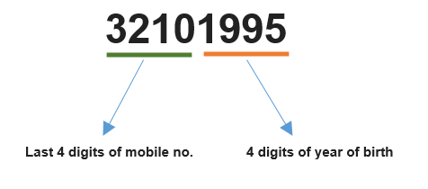
HOW TO REGISTER ?
For registration, you need to follow the following steps -

STEP 1 : Check if all your personal details are correct.
STEP 2 : Upload your recent passport size photograph. Face should be clear
STEP 3 : Upload your signatures. Signatures should be clear.
STEP 4 : Submit the Registration Form.
STEP 5 : Pay CBT Exam Fee Rs. 300/-
STEP 6 : Print

IMPORTANT :
In case you find any error in the details or you are not able to log in, please contact the school at……………………………

